Types of Autonomous Systems
# Source: Chatgpt (GPT‑5 Mini) at [12/15/2025]
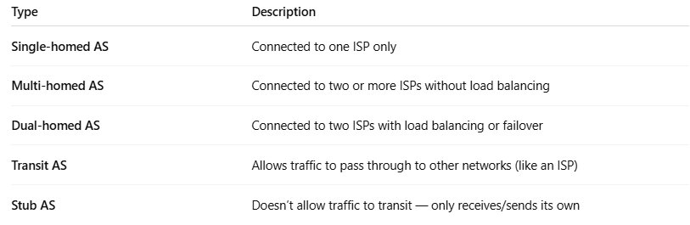
Type | Description
Single-homed AS | Connected to one ISP only
Multi-homed AS | Connected to two or more ISPs without load balancing
Dual-homed AS | Connected to two ISPs with load balancing or failover
Transit AS | Allows traffic to pass through to other networks (like an ISP)
Stub AS | Doesn’t allow traffic to transit — only receives/sends its own

